Reading Level 2 (Tinker v. Des Moines)
John and Mary Beth Tinker attended public school in Des Moines, Iowa. In December of 1965 a community group in Des Moines decided to protest American involvement in the Vietnam War by wearing black armbands. The Tinkers agreed to wear their black armbands to school. However, principals in the school district, aware of the students' plans created a rule that any student wearing an armband to school would be suspended unless the student removed the armband. Although the Tinkers knew about this rule, they decided to come to school wearing armbands anyway. After refusing to take the armbands off, John and Mary Beth Tinker were sent home by the principal. Their suspension lasted until they agreed to come back to school without the armbands.
The Tinkers filed a suit in the U.S. District Court to stop the school principals from enforcing the rule in the future. Although the District Court said that this type of protest was a form of expression protected under the First Amendment's freedom of speech clause, the Court sided with the school officials, saying that the rule was needed to "prevent the disturbance of school activities." The Tinkers appealed their case to the U.S. Eighth Circuit Court of Appeals, but they lost. The Tinkers decided to appeal the case to the Supreme Court of the United States.
The fundamental question of the case came down to this: Does the First Amendment's promise of free speech extend to the symbolic speech of public school students? And, if so, in what circumstances is that symbolic speech protected? The First Amendment to the Constitution says, "Congress shall make no law . . . abridging the freedom of speech." The Fourteenth Amendment extends this rule to state government as well, of which schools are a part. However, the First Amendment does not say which kinds of speech are protected. It also does not specify what types of expressive actions should be considered as speech.
The question of what kind of speech or action is protected under the First Amendment has been considered many times by the Supreme Court of the United States. Generally, the Court has held that the First Amendment protects adult symbolic speech that does not harm or threaten to harm.
However, at the time of Tinker, it was unclear whether students' rights in this area were different.
In 1968 the Supreme Court of the United States agreed to hear the Tinker's case and consider whether the Des Moines public schools ban on armbands was an unconstitutional violation of the students' right to free speech. The Court's decision in Tinker v. Des Moines was handed down in 1969.

QUESTIONS TO CONSIDER
- Do you think that the school policy banning armbands was fair? Why or why not?
- The students knew they would be suspended if they wore armbands to school and chose to do so anyway. Why do you think they ignored the rule?
- The First Amendment says "Congress shall make no law . . . abridging the freedom of speech." Why do you think the Supreme Court of the United States has ruled that certain actions should have the same protection as verbal speech? Are these reasons valid?
- Pretend that students in your school wanted to protest the school-wide ban on smoking. Should they be allowed to protest by wearing T-shirts that read "Up with 'Butts'!"? Why or why not?

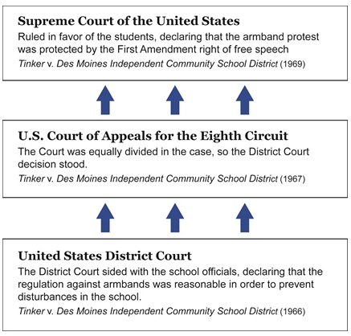

Reading Level 1 (Tinker v. Des Moines)
John and Mary Beth Tinker attended public school in Des Moines, Iowa in 1965. Their school did not allow students to wear armbands to protest the Vietnam War. However, the Tinkers decided to wear armbands to school anyway. The school officials asked the Tinkers to remove their armbands, but the Tinkers refused. John and Mary Beth Tinker were suspended from school until they agreed to remove the armbands.
The Tinkers sued the school district in the U.S. District Court. The Tinkers believed that the Des Moines school district violated their right to free speech under the First Amendment to the U.S. Constitution. Even though the students were not speaking with their voices, they believed that wearing armbands was like speaking. This is called symbolic speech.
The District Court sided with the school officials. The Court said that wearing the armbands could disrupt learning at the school. Learning without disruption was more important than the free speech of the students.
The Tinkers appealed their case to the next level of courts, U.S. Court of Appeals for the Eighth Circuit: But the Circuit Court agreed with the District Court. The Tinkers then appealed their case to the Supreme Court of the United States. The Court had to answer this basic question: Does the constitutional right of free speech protect the symbolic speech of public school students?
In 1968, the Supreme Court of the United States agreed to hear the case of Tinker v. Des Moines. They issued their decision in 1969.

- protest: To oppose or object to
- sued (to sue): To seek a remedy for a grievance or complaint in court
- violated (to violate): To break or disregard (a law or promise, for example)
- symbolic speech: Conduct that is intended to convey a particular message which is likely to be understood by those viewing it
- disrupt: To throw into confusion or disorder
- appealed (to appeal): To formally request that a lower court decision be examined and reconsidered by a higher court
- constitutional: In agreement with the principles set forth in the constitution of a nation or state

QUESTIONS TO CONSIDER
- Do you think that the school policy banning armbands was fair? Why or why not?
- The Tinkers knew they would be suspended if they wore armbands to school. They decided to wear the armbands anyway. Why did they do this?
- The First Amendment says "Congress shall make no law . . . abridging the freedom of speech." Do you think that actions, like wearing an armband to protest, are the same as speech? Why or why not?
- Imagine that students in your school wanted to protest the smoking rule. Do you think they should be allowed to wear T-shirts that read "Up with 'Butts'!"? Why or why not?

