Chapter 7 Reading Notes
Directions: Read each section one at a time. Answer the question for each section before moving on to the next section.
7.2 American Strengths and weaknesses
- List three weaknesses of the Americans at the start of the war.
1.
2.
3.
- Besides patriotism, list two American strengths at the start of the war.
1.
2.

7.3 British Strengths and Weaknesses
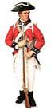
- List three strengths of the British at the start of the war.
1.
2.
3.
- List two weaknesses of the British at the start of the war.
1.
2.

7.4 Britain Almost Wins the War
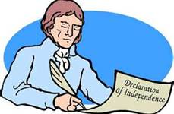
- Why did the Declaration of Independence increase Americans’ motivation to fight and win the war?

- For which group of Americans did the Declaration of Independence raise hopes as well as questions?

- What factors allowed the British to almost win the war in 1776?

7.5 A Pep Talk and Surprise Victories
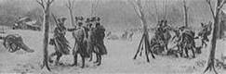
- What was the message of Thomas Paine’s pamphlet The Crisis? (use your own words)

- How were the Americans able to win such an overwhelming victory at Trenton?

- How did the victories at Trenton and Princeton affect American morale?

7.6 The Tide Begins to Turn
- As war progressed, how did Washington revise his military strategy?

- Why did the Americans cause look more hopeful after the Battle of Saratoga?

- Name two foreigners who were present with the Americans at Valley Forge, and explain how they helped the Americans.
- who:
What he did:

- who:
What he did:

7.7 The War Goes South
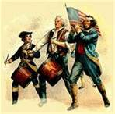
- What tactics did the Americans use successfully against the British in the Southern Colonies?

- How did the success of the Continental Army in the South contribute to the American victory?

- How did the French help the Americans in the Battle of Yorktown?

7.8 The War Ends
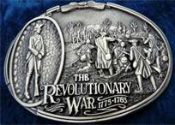

- How did the British people respond to news of the Battle of Yorktown?

- What were three key provisions of the Treaty of Paris?

1.
2.
3.

Processing 7
Directions: Create a Fourth of July parade banner that commemorates the reasons the Continental Army was able to defeat the British in the Revolutionary War. Check off the following requirements as you add them to your banner:
- Create a slogan on the top of banner below.
- Decorate the banner with five simple visual symbols that represent different reasons the Americans won the Revolutionary War.
- At the bottom of the banner, write a three-four word caption that explains what each symbol represents.

