Name ________________________________ Due Date: __________________

13 Colonies Project

Choose from one of the four following projects. You can choose to create a travel magazine for the group of colonies of your choice, write and present an “auto-biography,” blast into the past, or colonial chef extraordinaire! You have the opportunity to select the project that is most interesting to you, so you should put in your best effort to ensure that you are producing the best possible project!

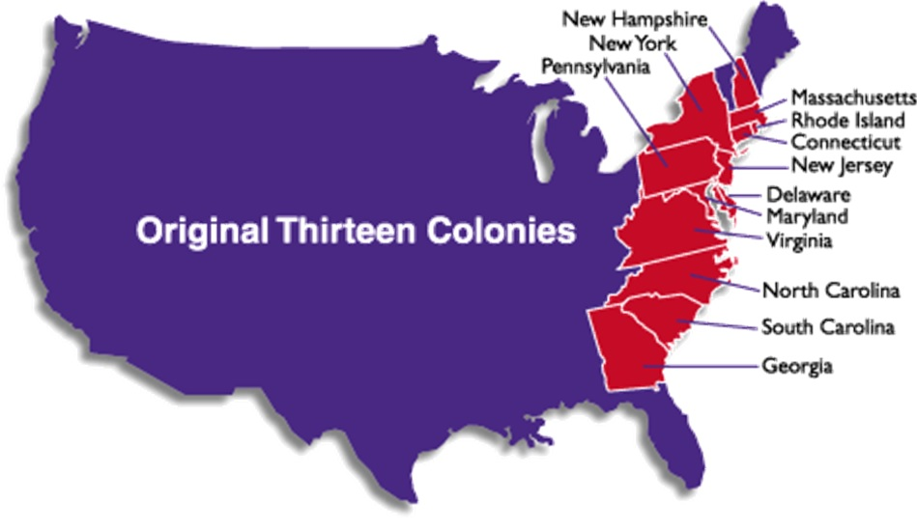
Colonial Magazine
Select the New England, Middle, or Southern Colonies as the topic of a travel magazine. As the author you will sell the colonies to your audience. You want them to visit and in turn provide revenue for your colonies. You will need to speak as if you are currently living in the time period and emphasize the best points about your colonies!

Your magazine will include the following:
1. Magazine cover
° Title of the magazine
° Date and issue
° Illustration or picture of the colonies selected
2. Information
° Climate and geography
° Important People
° Government
° Education, Lifestyle, and jobs
° Entertainment and recreation
3. Graphics
° Images that support the information.
° Can be a combination of Internet graphics, illustrations, and digital pictures.
4. Editorial
° 500 word “letter or the editor,” This should be an editorial on your personal travel experience in the colonies and why your enjoyed it. What were your favorite things to do? Places to eat?
° Sources for all images or informational sources must cited.

Auto-Biography
1. Research information about a colonist from any of the 13 colonies.
° Birth date, birth place, date of death
° Main events in life
• Family
• Education
• Career
° Where he/she traveled
° Contributions to colony or colonies
° Any other fascinating or interesting information about your colonist’s life
2. Create a PowerPoint of the person’s life to accompany your speech.
3. Write a 400-800 word speech, combining all of your research, explaining the highlights of your (the colonist you selected) life. You must use first person point of view.
4. Dress up as the colonist and present your speech in the first person. You will become this person!
° Sources for all images or informational sources must cited.

Blast into the Past
One night you fell asleep in your own bed but when you woke up you found yourself in Colonial America. Choose your favorite colony and write a 1500-2000 word story about your new life in the colony. Your adventure must include the following components.
1. Introduction
2. Εϖεντσ μυστ σπαν οϖερ At least a 4 week time period
3. Main events that describe:
• The people you lived with
• Daily work you completed
• School and activities
• Games you played
• Religion and government of the colony
• At least one famous historical person you encountered
• Examples of how you completed daily tasks without the use of today’s technology and modern luxuries
4. Detailed explanation for how you traveled back to the present
5. Conclusion describing how your experience changed you
6. A cover and title page for your story with at least one image or illustration
° Sources for all images or informational sources must cited.

Colonial Chef Extraordinaire
You are a chef best known for authentic colonial cooking. You will create a cookbook that represents authentic recipes from the thirteen colonies. Your cookbook must include the following:
1. At least 10 recipes you have researched from online and print resources. You may not print recipes from the Internet. You must write or type the recipes and decorate each page to look like they belong to the same book. All cooking instructions must be included!
2. A decorative cover made from cardboard or poster board. Consider covering cardboard in fabric.
3. Background for each recipe must include:
• Where did it come from?
• For what occasions was it prepared?
4. You must also demonstrate one of your recipes to the class during a “cooking show.” You will describe the steps you are following to prepare the dish. Since you will not be able to cook anything in class, you should bring a previously prepared dish to show what the outcome will be. Dressing up in “authentic style” clothes for your presentation will earn you a few bonus points.
5. Write a 300-600 word report on how you would go about acquiring the foods that you need for your recipes. This needs to be researched. Example: I gathered fresh farm eggs from the coop, purchased whale blubber at a local fish market caught off the Atlantic Coast, etc.
° Sources for all images or informational sources must cited.

