Reading Level 1 (Hazelwood v. Kuhlmeier)

The journalism class at Hazelwood East High School wrote articles and put them together for the school paper. They gave the newspaper to their teacher, Howard Emerson. Mr. Emerson showed the newspaper to the principal. He asked the principal if it was okay to make copies and hand them out to students at the school.
Principal Reynolds did not like what he read. First, there was an article about pregnant students. It described the students, but it did not give their names. Principal Reynolds was afraid that students would be able to figure out who the pregnant students were. He also noticed that the article mentioned sex and birth control. He did not think that students in ninth grade should be reading about sex and birth control.
There was another article that Principal Reynolds did not like. This one talked about divorce. In it, one student said things about her father. For example, she said that her father went out too much. She also said that her father didn't spend enough time with his family. The father did not get a chance to tell his side of the story. Principal Reynolds thought this was unfair.
Principal Reynolds thought the paper needed to be changed. But it was almost the end of the school year. He was afraid that it would take the class a long time to change it. If it took too long, the school year would be over and the other students would not get the paper. So he told Mr. Emerson to remove the pages that had the articles about pregnancy and divorce. He said to make copies of the rest of the paper.
The students were very angry. They had spent a lot of time writing the articles. They could have fixed them if Principal Reynolds had given them a chance. Instead, he deleted two pages that also contained other articles. They felt that this was a violation of their First Amendment rights. They went to the U.S. District Court. The court did not agree with them. It said that school officials may limit students' speech in the school newspaper if their decision has "a substantial and reasonable basis." In other words, if he has a good reason, it is okay for a principal to limit students' speech.
The students appealed the decision. The Court of Appeals reversed the decision of the U.S. District Court. This court said that the school paper was a "public forum," or place where students could express their views. The judges said that the school could not censor the paper except "to avoid . . . substantial interference with school work or discipline . . . or the rights of others." They did not think that the articles about pregnancy would have interfered with schoolwork. They thought the articles should have been printed.
The school appealed the decision of the Court of Appeals. The Supreme Court of the United States thought that this was an important case. It dealt with the rights of students. It agreed to hear arguments from both sides.
- removed (to remove): To take away or eliminate
- violated (to violate): To break or disregard (a law or promise, for example)
- appealed (to appeal): To request formally that a lower court decision be examined and reconsidered by a higher court
- reverse: To overturn the decision of a lower court and decide the case differently
- interfered, interference (to interfere): To create a distraction or obstacle
- censor: To examine and remove information to prevent others from access to it

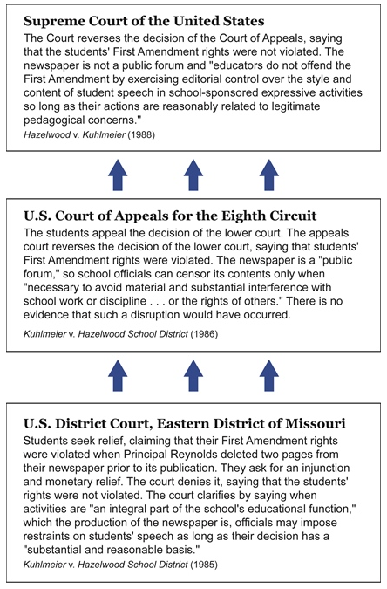
QUESTIONS TO CONSIDER
- In the article about the pregnant students, what was Principal Reynolds worried about?
- What did Principal Reynolds say was wrong with the article about divorce?
- What did Principal Reynolds do to fix the problem? Did he have any other choices?
- What rights did the students say had been violated?
- Do you think a principal should be allowed to limit what is said in a school newspaper? Why or why not?

Reading Level 2 (Hazelwood v. Kuhlmeier)

In May 1983, students in the Journalism II class at Hazelwood East High School in St. Louis, Missouri, created the final edition of the school paper, the Spectrum. Before publishing the paper, they submitted it to their advisor, Howard Emerson, so he could review it. Emerson was new to the job, so he followed the procedures of the previous advisor. Those guidelines required him to give Principal Robert Reynolds, the opportunity to review the paper before it was published.
When Principal Reynolds reviewed the paper, he found two articles that concerned him. The first dealt with the issue of teen pregnancy. It included comments from pregnant students at the school. To protect their privacy, names were not given. However, when Reynolds read the article, he realized that the details in the article would make it easy for other students to identify the pregnant teens. The second article addressed the issue of divorce. Like the first article, this one included personal articles. One student, whose parents were divorced, made negative comments about her father. She said that her father was always out with the guys and that her father didn't spend enough time with the family. Principal Reynolds was troubled by the fact that the father had not been given a chance to defend himself by responding to his daughter's comments. He also noticed that the article mentioned sex and birth control. He did not think that students in ninth grade should be reading about sex and birth control.
Reynolds wanted the journalism students to modify the articles. However, it was almost the end of the school year. If they took the time to revise, they would miss the deadline for publishing the newspaper. If that happened, the other students might never get to read the paper. He felt like he had to act quickly, so he told Emerson to delete the two pages with the offending articles and publish the rest of the Spectrum. He told his supervisors about this decision and they agreed with him.
The students had worked hard on the paper and felt that they had followed proper journalism procedures. If they had been approached about the problems, they may have been able to correct them. They were upset to find out instead that two pages, which included a number of non-offensive articles, had been deleted. They felt that their First Amendment rights had been violated. They took the case to the U.S. District Court for the Eastern District of Missouri.
The Court did not agree with the students. In the ruling, the judges said that school officials may impose limits on students' speech in activities that are "an integral part of the school's educational function" as long as their decision "has a substantial and reasonable basis." In other words, the Court felt that if the school has a good reason to do so, it can place limits on curricular activities, such as the publication of the school newspaper.
Unhappy with the outcome, the students appealed their case to the Court of Appeals for the Eighth Circuit Court. This court reversed the decision of the lower court, saying that the students' First Amendment rights were violated. In the opinion, the Court explained that the newspaper was part of the school curriculum but was also a "public forum." As a public forum, the newspaper was "intended to be and operated as a conduit for student viewpoint". Because the paper was a forum for student discussion, the principal or other officials could censor it only when "necessary to avoid material and substantial interference with school work or discipline… or the rights of others."
The school appealed the decision of the Court of Appeals and the Supreme Court of the United States agreed to hear the case. In determining whether or not students' rights were violated, it would consider whether or not the student newspaper was a public forum and whether the First Amendment "requires a school affirmatively to promote particular student speech."

QUESTIONS TO CONSIDER
- Why did the newspaper advisor give the paper to Principal Reynolds for review? Was that standard procedure?
- What concerns did Principal Reynolds have regarding the two articles? Were these legitimate concerns? Were there other ways that the principal could have handled the situation?
- Do you think Principal Reynolds was justified in deleting the two pages of the paper? Should a principal be able to censor student newspapers? If so, under what conditions?
- What rights did the students believe had been violated?
- Were there any steps the students could have taken other than filing a lawsuit?
- Should a principal or other school authority be able to silence other forms of student speech? If so, under what conditions? How does speech by an individual student differ from speech by the school newspaper?

